**Healthcare IT Data-Quality Risk-Mitigation Strategy**

**“How to manage healthcare IT risk by standardizing data”**

**Considering 21st Century Cures Act, TEFCA and USCDI**

HL7 (CIC, PHER, EHR, CQI, CDS, CIMI) Workgroups, Steve Hufnagel facilitator

In December 2016, the *21st Century Cures Act* was signed into US law. It provides the healthcare IT industry with stronger definitions for “interoperability” and “information blocking” while sketching the first outlines of a financially-driven penalty system for those who fail to ensure the free flow of patients’ healthcare data.

In January 2018, Health and Human Services (**HHS**) Office of the National Coordinator (**ONC**) released the TEFCA and USCDI draft policy documents that promise profound impact on the activities and priorities of Health Information Networks (**HINs**), provider organizations that participate in them and the vendors that work to provide health IT (**HIT**) services. Once final, TEFCA and USCDI will define US policy for interoperability.

* Draft Trusted Exchange Frame-work and Common Agreement (**TEFCA)** strives to establish a single “on-ramp” for Healthcare Information Exchange (**HIE**) to enable providers, hospitals and other healthcare stake-holders to join any health information network (**HIN**) and then to automatically connect and participate in nationwide health information exchange (**NHIN**). TEFCA establishes “Qualified HINs” (**QHINs**) as a vehicle to help facilitate a standardized methodology for HIE inter-connectivity, along with a new administrative organization, the Recognized Coordinating Entity (**RCE**).
* Draft U.S. Core Data for Interoperability (**USCDI)** begins with the Common Clinical Data Set (**CCDS**) required by ONC’s 2015 Certification Criteria; where, USCDI adds two new data classes: structured-and-unstructured Clinical Notes and Provenance. USCDI outlines a progression in the USCDI data set to include more data, categorizing additional data classes being considered as “candidate” and “emerging” data in ONC’s USCDI expansion roadmap.

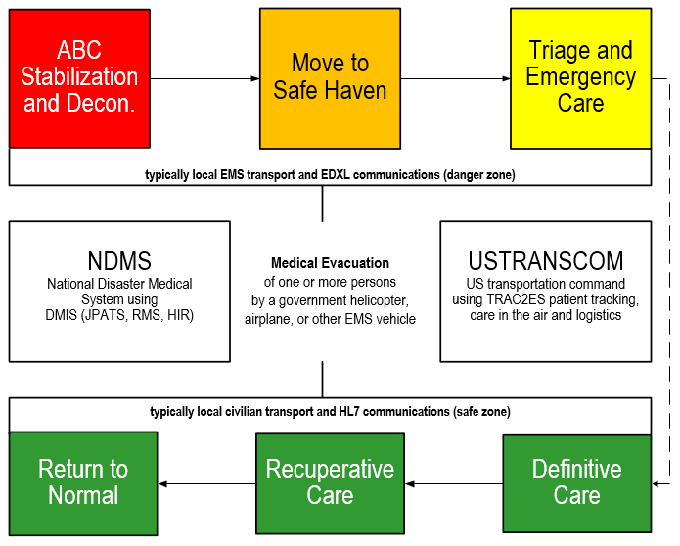

**Figure 1: Emergency-Management Patient-Movement Continuum-of-Care Scenario**

The Figure 1’s, Emergency-Management Scenario defines the worst-case highest-value TEFCA-USCDI healthcare IT computable-interoperability requirements; where, electronic medical records move with patients. The goal is to help people live the healthiest lives possible. The objective is continuously-improving learning health systems. *Emergency-management adds requirements for computable-interoperability amongst disparate partners collaborating with an ad-hoc set of heterogeneous systems, during patient-movement episodes across a disaster-response continuum-of-care*.

* The 50-year data-quality lesson-learned and conundrum is clinicians prefer pre-coordinated data-entry terminology while analysts prefer post-coordinated normalized controlled-terminology forms. Inconsistent pre-post coordinated data mapping is an inherent data integrity risk. Mapping is complicated by different granularities and ontologies across-and-within standards.
* Regardless of vendor, EHR data-entry Electronic Healthcare Record (**EHR**), analytic/reasoning Enterprise Data Warehouse (**EDW**) and HIE exchanges are subject to this data-quality conundrum.

**Example**: pre/post coordinated data-representation forms.

1. In a pre-coordinated coded clinical entry form, multiple concepts are brought together in one term. Pre-coordination allows for disambiguation of the relationship of the concepts into one term that might not be possible in post-coordinated systems – pre-coordinated entry order is relevant. For example,
   * + Clinicians text notes: “closed displaced-fracture on the right leg at the neck-of-the-femur”
     + ICD-10-CM, EHR billing form: displaced-femur fracture type III
2. In a post-coordinated or normalized data-analytic form, concepts are kept broader and separate to be selected and joined with Boolean operators in the process of searching.
   * + A post-coordinated representation of the above might be "fracture AND femur AND neck AND displaced AND right leg AND closed" – in post-coordinated representation, order is irrelevant.
     + SNOMED CT analytic form: fracture (morphologic abnormality), structure of neck of femur (body structure), right (laterality), plus primary procedure (qualifier value), etc.
3. Data quality solutions that are both optimized for clinician data entry, analytics and reasoning, require clinician data-entry bi-directional mapping, without loss of information, to normalized analytic post-coordinated form; where, clinical findings have multi-faceted context, such as workflow, provenance and intended use.

**Recommendation**: *The 21st Century Cures Act’s Health Information Technology Advisory Committee (****HITAC****) USCDI task force align the many informatics considerations, technologies, methodologies and tools into a National data-quality US Core USCDI-FHIM-DCM stewardship-and-governance process, technology-tools and methodology to achieve efficient-and-effective bi-directional mappings, without loss of information; where, pre/post coordinated mappings are standardized and shared as an FHA-managed US Realm SNOMED CT extension, including LOINC and RxNorm.* The good news is that this pragmatic risk-mitigation strategy has no impact on currently-deployed EHR-systems. But, EHR-EDW Extraction, Transfer and Load (**ETL**) processes and EDW and HIE content are at risk. Federal Agencies, partners, venders and contractors should incorporate modern best-practices, methodologies, technologies and tools to mitigate TEFCA-USCDI data-quality risk, as described next.

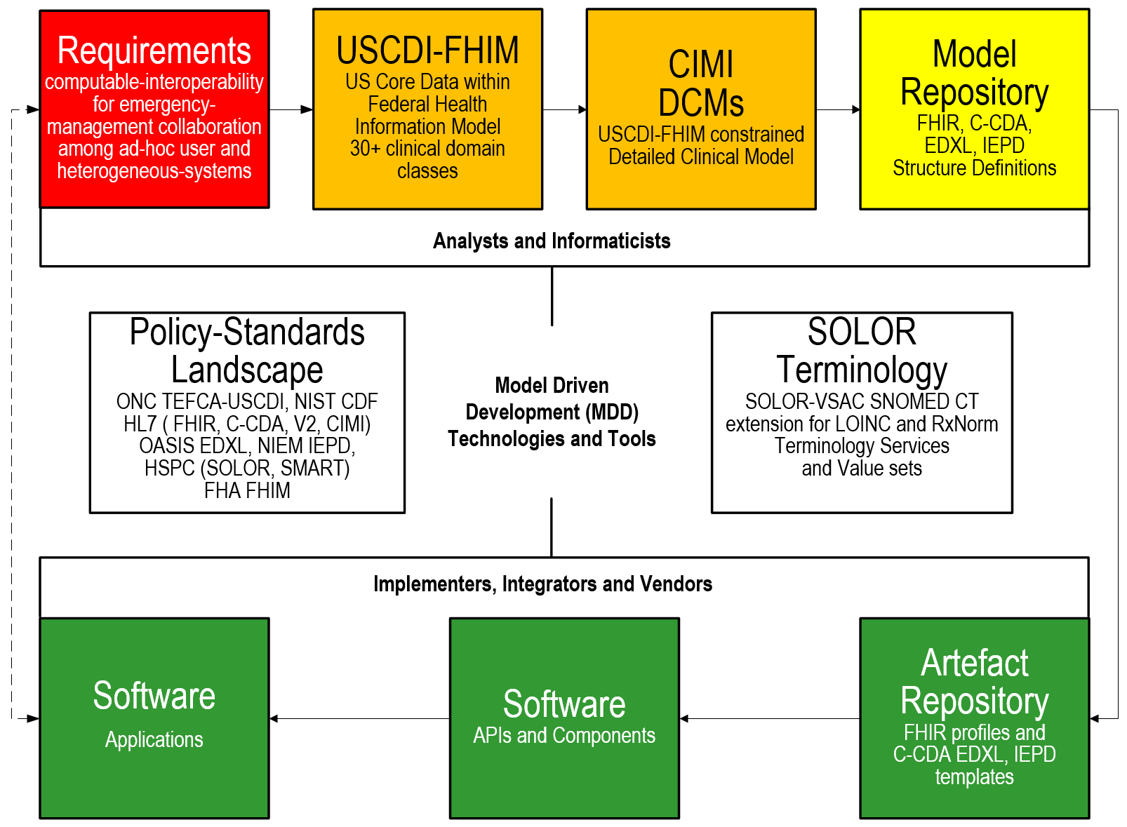

**Figure 2: TEFCA-USCDI-FHA-HL7-HSPC Data-Quality Risk-Mitigation Methodology.**

In Figure 2, The data-quality risk-mitigation methodology uses USCDI-FHIM-HL7-FHA-HSPC-MITRE model driven development (**MDD**) technologies and tools. These projects separate structure-and-semantic concerns making complex risks manageable. The pre/post coordination mapping conundrum is addressed by a use-case specific constrained USCDI-FHIM domain models into CIMI Detailed Clinical Models (**DCMs**) harmonized across-and-within SOLOR controlled vocabularies (**CVs**) and code sets; where, a DCM associates a SOLOR model-of-meaning using the SNOMED observation model, which then associates a DCM (Finding, Order or Procedure) template with its context. Seamless MDD tools, such as those developed by FHA, HL7, MITRE and commercial partners make the methodology efficient-and-effective.

**Benefit**: Computable interoperability within Health Information Networks (HIN), Qualified HINs (QHINs) and Recognized Coordinating Entity (RCE) by standardizing pre-post coordinated terminology mappings and value sets within an FHA managed USCDI-FHIM-DCM US-realm SNOMED extension for LOINC and RxNorm can positively influence patient-value (safety, quality, cost), by empowering better analytics, reasoning and outcomes measurements.

**Acknowledgement:** This paper would not be possible without

* Thought leadership: Stan Huff, Keith Campbell, Nona Hall, Mark Kramer, Walter Sujanski, Rob McClure, Susan Matney, Jay Lyle, Claude Nanjo, Richard Esmond, Galen Mulrooney, Sean Muir, Gerard Freriks, HL7-HSPC participants.
* Mentoring, focus and encouragement: Nancy Orvis, Gail Kalbfleisch, Bob Bishop and Steve Wagner.

**Call for Participation**: Send questions and suggestions to stephen.hufnagel.HL7@gmail.com facilitator

**Attachment:** Extended Wounded-Warrior Scenario Version

**Healthcare IT Data-Quality Risk-Mitigation Strategy**

**“How to manage healthcare IT risk by standardizing data”**

**Considering 21st Century Cures Act TEFCA and USCDI**

**Executive Summary**

The MHS GENESIS Initial-Operating-Capability deployment identified the data-quality risk discussed in this paper, which is also applicable to the planned VistA Modernization deployment of Cerner Millennium EHR and Cerner HealtheIntent EDW. The good news is that this pragmatic risk-mitigation strategy has no impact on current-or-planned MHS Millennium EHR system deployments; but, the EHR Extraction, Load and Transfer (ETL) process and EDW are at risk. DoD-VA EHR modernizations can be a high value demonstration of the recommended TEFCA-USCDI-FHIM-CIMI-SOLOR positive patient-value impact during wounded-warrior patient-movements across the emergency-management continuum-of-care.

Standardized USCDI-FHIM-DCMs with SNOMED CT extension including Extraction, Transformation and Load (**ETL**) process from core EHR “Bespoke” data model’s bi-directional data mapping, without loss of information, to a normalized analytic post-coordinated form maintained-and-governed independent of the operational EHR systems’ deployments is recommended. This ETL focused strategy also applies to legacy data and Health Information Exchange (**HIE**) data-sharing. If operationalized at a national and ideally international level, the strategy can meet the worst-case, high-value combat-casualty and disaster-management use-cases’ requirement for computable-interoperability amongst disparate partners collaborating within an ad-hoc set of heterogeneous systems, during a wounded-warrior or medically-impacted civilian patient-movement episode across an emergency-management continuum-of-care. The pragmatic dual-use strategy uses ONC-FHA-NIST-OASIS-HL7-NIEM-HSPC-MITRE standards, policies, methodologies, technologies and model-driven-development tools for federated EDXL-FHIR-CDA-IEPD APIs, and reference implementation (guides, test-fixtures, methodologies, technologies, tools, components, software development kits) using US Core Data for Interoperability and US SNOMED extension for LOINC and RxNorm terminology by Federal Agencies, partners, researchers, venders and contractors.

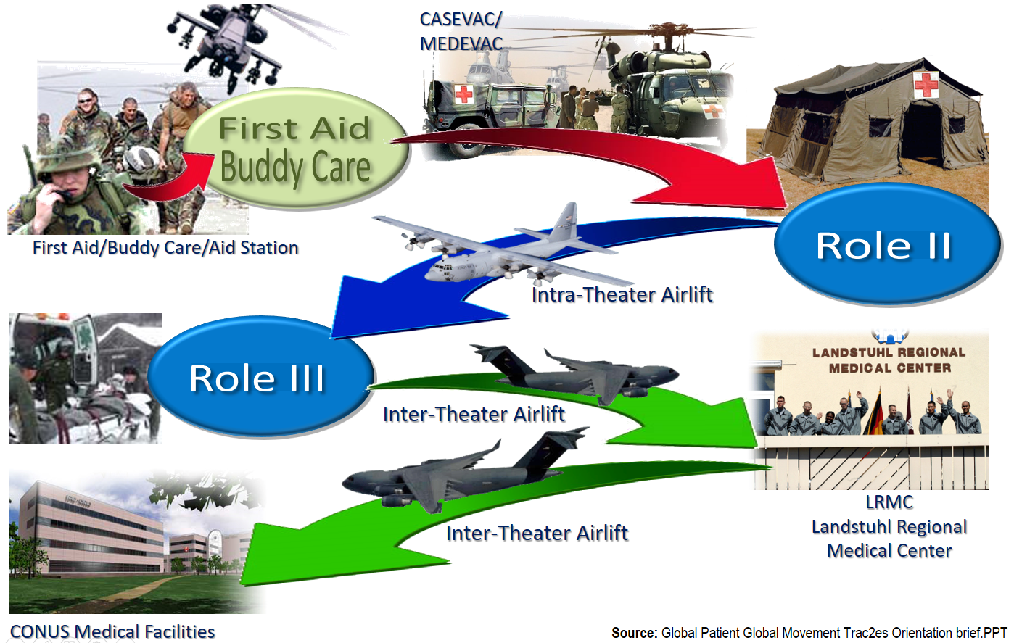

**Figure 3: Wounded Warrior Continuum-of-Care Scenario; where, Information Moves with Patients**

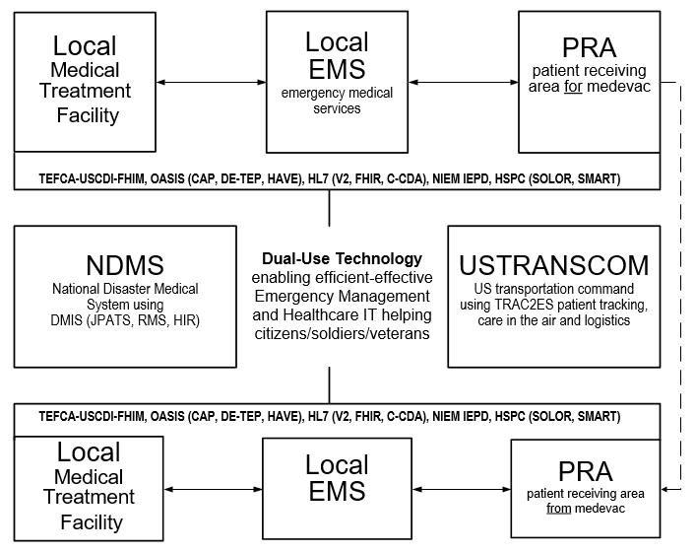

**Figure 4: Notional Emergency-Management Healthcare IT Use-Case**

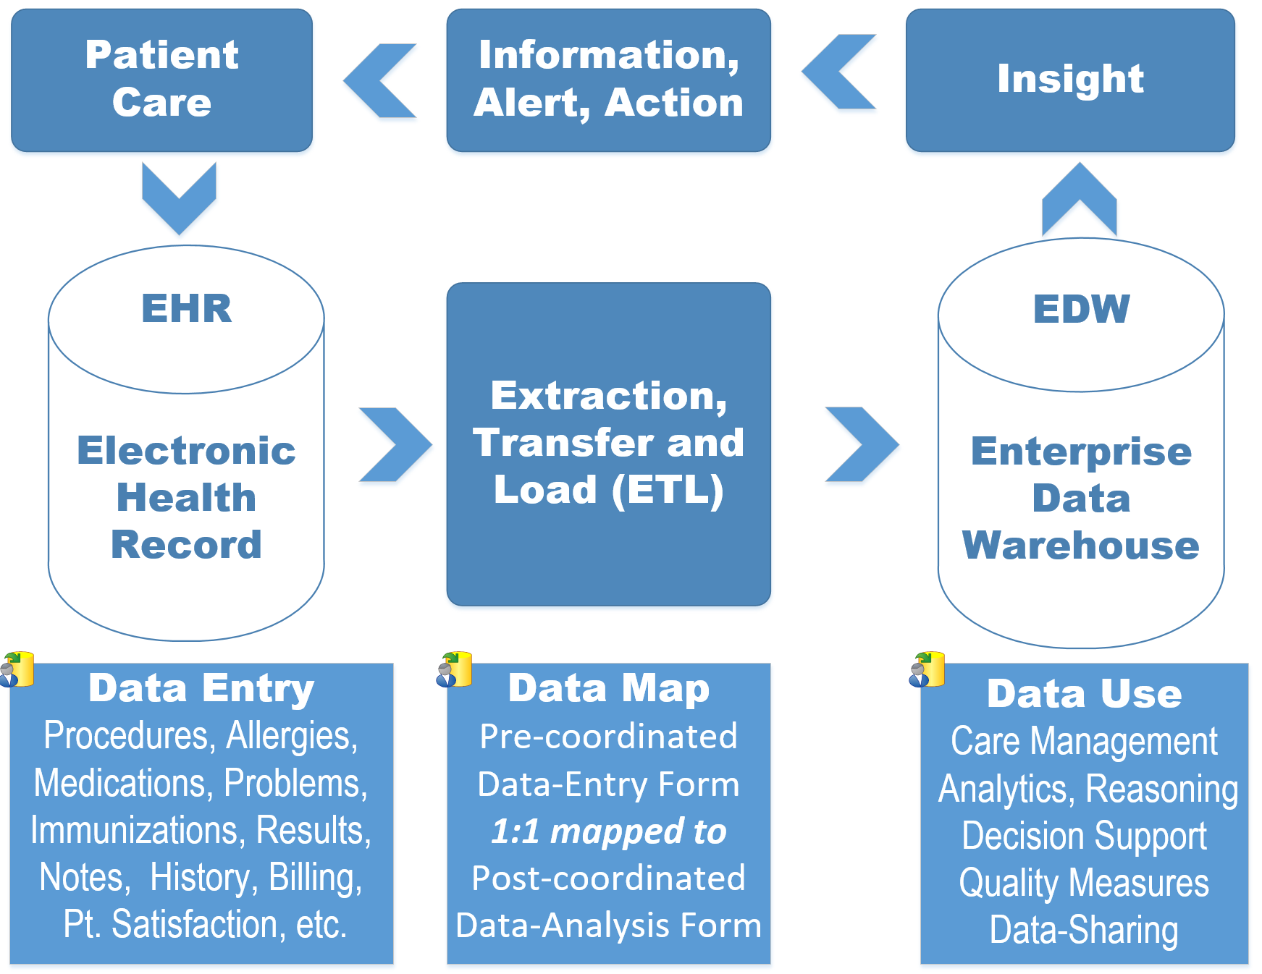

**Figure 5: Health IT Value Cycle:** Data Quality is the Lynchpin to Patient Value (safety, quality, cost).

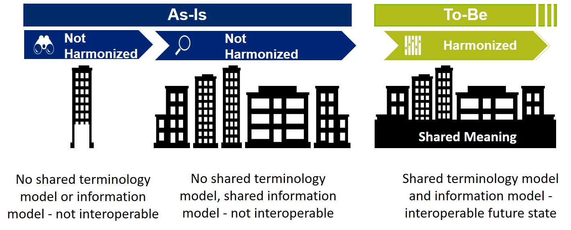

**Figure 6: Issue: Data Integrity within-and-across Communities of Interest**

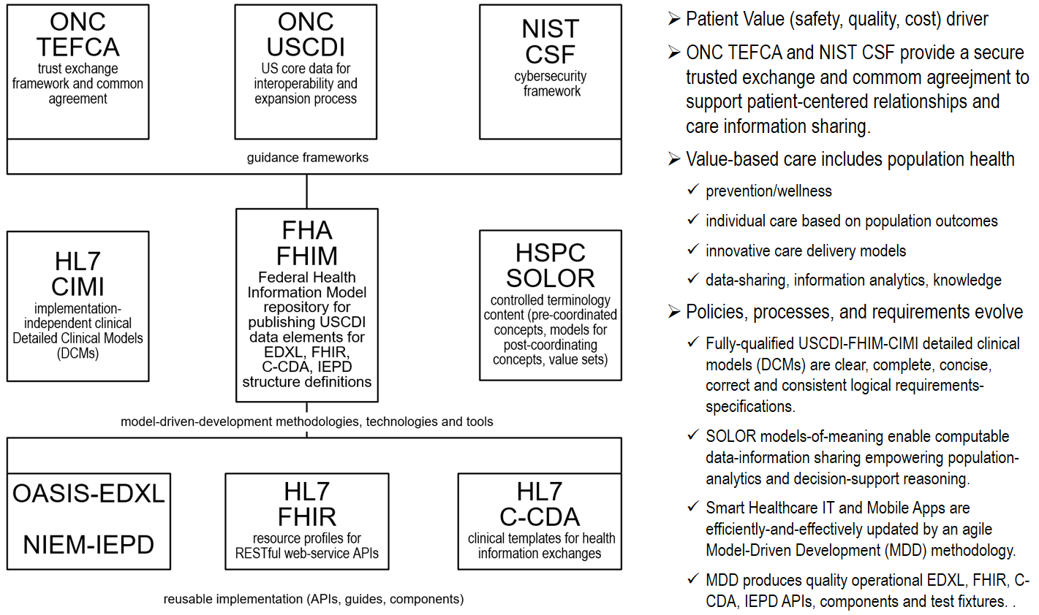

**Figure 7: 21st Century Cures Act Data-Quality Risk-Mitigation Landscape**

**Benefit**: Computable interoperability within Health Information Networks (**HIN**) partners and among Qualified QHINs. This can positively influence the Recognized Coordinating Entity (**RCE**) and QHINs by sharing the ETL pre-post coordinated USCDI mappings and value sets within an HHS: FHA managed US Core Data for Interoperability and US realm SNOMED extension for LOINC and RxNorm.

* ONC TEFCA and NIST CSF provide a landscape; where, health IT encoding-layer's normalization with fully-qualified USCDI-FHIM-CIMI logical design-specification structural-models resulting in clear, complete, concise, correct and consistent operational EDXL, FHIR, C-CDA, NIEM APIs and components.
* SOLOR models-of-meaning empower data-sharing empowering population-analytics and decision-support reasoning, which can positively impact patient safety and quality of care while reducing costs.

**Introduction**: Our goal is to help people live the healthiest lives possible. Our technical objective is continuously-improving learning health systems. The 50-year data-quality lesson learned, and conundrum is, clinicians prefer pre-coordinated data-entry terminology while analysts prefer post-coordinated normalized controlled terminology forms. Inconsistent pre-post coordinated data mapping is an inherent data quality risk. Mapping is complicated by different granularities and ontologies across and within standards. EHR data-entry Electronic Healthcare Record (**EHR**) and analytic/reasoning Enterprise Data Warehouse (**EDW**) and HIE exchanges are subject to this data-quality conundrum. The data quality conundrum and recommended risk mitigation strategy is universally applicable, regardless of the vendor.

The data-quality risk-mitigation strategy includes the uptake of modern best practices manifested in US Core Data Interoperability (USCDI) terminology, HL7 clinical statements aka detailed clinical models (DCMs) models and SNOMED CT observation models and expressions for semantic meaning and context to specify pre-post coordination bi-directional ETL mapping, without loss of information. This approach is being standardized at HL7 and operationalized at organizations, such as Healthcare Services Platform Consortium (**HSPC**) and can improve data-sharing computable-interoperability, outcome-measures, population-analytics, and point-of-care semantic-reasoning.

1. TECFCA starts with a trusted exchange framework for policies and practices and for a common agreement for the exchange between HINs, with four important outcomes: 1) providers can access health information about their patients, regardless of where the patient received care; 2) patients can access their health information electronically without any special effort; 3) providers and payer organizations can receive necessary and appropriate information on a group of individuals without having to access one record at a time to analyze population health trends, outcomes, and costs; identify at-risk populations; and track progress on quality improvement initiatives; and 4) the health IT community has open and accessible application programming interfaces (APIs) to encourage entrepreneurial, user-focused innovation to make health information more accessible and to improve electronic health record (EHR) usability.
2. USCDI requires government, industry and academia collectively work towards defining the data that needs to be exchangeable, prioritizing the development of technical standards and implementation guidance to support the exchange of such data, and, ultimately, implementing those capabilities in health IT at the point of care.
3. FHIM builds standard structures using consistent terminology using standard code/value set(s), Unit(s) of Measure by aligning with HL7 clinical statement structures,
4. SOLOR’s SNOMED CT observation model, expressions and translators support local databases, CDA, FHIR, HL7 V.2, etc. with computable semantic content.
5. At the operational level, this recommendation requires EHR clinician data-entry files and tables be fully-qualified as post-coordinated SNOMED concepts; where fully-qualified means the EHR files and tables maintain associated clinical-context-specific pre-post coordination mappings to support EHR extraction, transformation and load (**ETL**) to EDW., e.g., workflow-provenance (who, what, when, where, why, how), Clinical related event/action, condition, circumstance, diagnosis, indicators of performance, quality, outcome, and potentially include administrative/operational allocation, deployment, resource utilization, costs, productivity, work load might be needed for intended usage.
6. Enterprise data stewardship curation and governance processes, such as MHS GENESIS and VistA Modernization, be expanded to oversee the file-table ETL context-specific ETL mapping table configurations, for all data entry terms, value and code sets and numeric or Boolean entries, e.g., smoking status = yes/no.

Model-based clinical-structures are being standardized at HL7 CIMI. CIMI design-time models are being operationalized by Healthcare Services Platform Consortium (**HSPC**) SOLOR terminology models-of-meaning encoding layer supporting run-time ETL for implementation components supporting data-sharing, population-based analytics and clinical decision-support reasoners.

* USCDI with HL7 CIMI Detailed Clinical Models (**DCM**s), FHA FHIM domain models and HSPC SOLOR run-time controlled terminology and value sets can positively impact computable interoperability; where, USCDI, CIMI models and SOLOR terminology live at different levels of the software development "stack". USCDI-FHIM-CIMI support logical specifications. The pre-coordination/post-coordination question applies to CIMI detailed clinical model (**DCM**, also known as a clinical statement) and subsequent FHIR, CDA implementation templates and SOLOR run-time terminology value set servers.
  + CIMI supports equivalent design-time clinical statement specifications, which have 1:1 iso-semantic* pre/post coordinated forms to reduce variability across OASIS EDXL, HL7 FHIR, CDA and V2 product families and implementations.
  + Imagine that one CIMI DCM for blood pressure is highly pre-coordinated, and another is highly post-coordination. Transforming between these iso-semantic models is necessary and achievable requirement, within reasonable constraints.
  + Accurate implementations require:
    - Normalized 1:1 pre/post coordinated mapping to ensure accurate analytics, reasoning and patient safety.
    - Consistent use of terminology within the CIMI models enables essential 1:1 pre/post coordinated mappings.
* HSPC/VA SOLOR encoding layer supports run-time implementations. To best implement SOLOR (call this the encoding layer) in EHR modernizations, the pre-coordination/post-coordination question really does not apply. We simply want to make sure that any content in a "bespoke* EHR system" is exported, and added to a SOLOR extension as an equivalent concept (not broader or narrower), with an appropriate post-coordinated logical definition. So, all the pre-coordinated primitives, and all the post-coordinated parts that are not already equivalently represented in standards, need to be added to the extensions to those standards. This ensures 1:1 pre/post coordination mappings. Now, we can consistently share clinical concepts amongst ourselves, our care partners, and with the organizations responsible for the standards; where, these clear, complete, concise, correct and consistent clinical statements are suitable for safe analytics and reasoning.

**Notes**

1. “*Bespoke*” is an adjective for anything commissioned to a particular need. Bespoke EHR terminology meets their clinician customer needs; where, an EHR data model/dictionary is optimized for clinician entry and associated billing.
2. *“Iso-semantic models*” imply that pre/post coordinated representations have bi-directional, without loss of information, pre-defined representation. In our case, defined as a SOLOR extension and has round-trip-able pre/post coordinated forms.
3. The storyboard and paper are intended to be re-titled, re-templated, re-authored and re-purposed for specific target audiences. Each policy-standard-technology-tool perspective potentially requires use-case and scenario refinements and re-scoping to specific needs and audience discussions, presentations and white papers.

**Background**: A repeated lesson learned is, clinicians prefer pre-coordinated terms; while, analysts prefer post-coordinated terms. Pre/post-coordinated term mapping is complicated by differences of controlled Vocabulary (**CV**) term or code granularities across overlapping standards, e.g., SNOMED, LOINC, RxNorm, ICD, CPT, etc. This mapping conundrum results in a potential patient safety, quality of care and cost data-quality risk. Once understood, this is a statement of the obvious; where, EHR modernization initiatives should avoid repeating the mistakes of the past.

Current situation is,

* An EHR data model is appropriately optimized for pre-coordinated clinicians’ data entry and billing codes; while,
* An EDW is appropriately optimized for population-based analytics, e.g., knowledge based reasoning and clinical decision support systems.
* Viewers and notifications are appropriately optimized to efficiently assist clinicians with pertinent point-of-care knowledge, advice and patient-safety alerts.
* The mapping conundrum is:
  + An EHR system must have consistent extraction-transfer-and-load (ETL) between the pre-coordinated clinical entry form and enterprise data warehouse post-coordinated normalized analytical form.
  + Moreover, the mapping must be 1:1 “round trip-able, without loss of information” between pre/post coordinated forms to support data-entry, information-analytics, knowledge-based reasoning, clinical decision support and viewing. We use standard terminologies; where, this problem is complicated by inconsistent ontologies-and-granularity across terminologies, e.g., SNOMED, LOINC, RxNorm, ICD-10, CPT

An example granularity issue is, patients have been confirmed to have allergies to mollusks, crustaceans, and certain varieties of fish. “Seafood” is an attempt to generalize one or more of these concepts, but the term seafood is ambiguously used across controlled vocabularies resulting in a non-actionable term, when presented in in a viewer or as an alert.

* + Discussion: The term seafood would exclude snails, which are mollusks, or may be taken to exclude freshwater fish. Its use should be avoided. However, the data show an overwhelming use of this term. In addition, “shellfish” should be disambiguated as either mollusks, crustaceans, or both.

Informatics SMEs categorize terms (aka ontologies) and define principles, which can be clinically valid and actionable >80% of the time. When terms are not clinically actionable and cannot be used to guide decisions unambiguously; e.g., “mold” (environmental respiratory issue, or a specific sensitivity?), “antibiotics” (in the unlikely event all sub-sets of antibiotics are contraindicated, they should be contraindicated explicitly), “tape” (unclear whether there is an adhesive substance sensitivity or a skin integrity concern).

* + Recommendation: In this seafood example,
    - Do not use the term seafood. Rather, consistently use specific terms or codes for fish, mollusks or crustaceans.
    - Do not use the term shellfish. Rather, consistently use specific terms or codes for mollusks or crustaceans.

A potential data-quality way forward is to harmonize the methodologies and technologies of the HL7 IIM&T project led by Dr. Stan Huff of Intermountain Health, the HSPC SOLOR project led by Dr. Keith Campbell of the VA, the FHIM project led by Steve Wagner of HHS-FHA, using harmonized HL7, FHA, VA, MITRE, Penrad and Cognitive developed open-source tooling. These projects are separating structure and semantic concerns making complex risks more manageable. The pre/post coordination mapping conundrum is addressed by a use-case specific methodology, constraining USCDI-FHIM domain models into CIMI Detailed Clinical Models (**DCM**s) harmonized across-and-within SOLOR controlled vocabularies (CVs) and code sets; where, a DCM associates a SOLOR model-of-meaning using the SNOMED observation model, which then associates a DCM Finding (observation, order, procedure, etc.) with its context and provinance. Seamless Model-driven Development (**MDD**) tools make the methodology efficient-and-effective.

Dr. Keith Campbell’s SOLOR Team, at the VA and HSPC, is harmonizing across controlled vocabularies (CVs) and code sets. SOLOR does not force a pre-coordinated/post-coordinated choice… SOLOR assumes that both pre-coordinated & post-coordinated strategies will continue to be used as chosen by the implementer. The basic SOLOR requirement is that regardless of choosing pre-or-post coordination, you put any concepts (including concepts intended for pieces of a post-coordinated expression) that are not part of the standard into an extension that you can share.

* a clinical observation/statement/note or lab/pharmacy/discharge/procedure order should each have a DCM for the Finding type and associated context expressions containing the provenance (who, what, when, where, how) for associated events, e.g., order writing, filling, refilling, renewal, cessation.
* observation/order/procedure/problem DCMs contain SOLOR codes
* Each observation/order/procedure/problem codes value can have many associated SNOMED context-expressions, aka SNOMED expressions of meta-data, e.g., anatomical location, laterality and attributes as well as basic event provenance.
* SOLOR uses Ontoserver, which supports classification… VSAC et al, do no such thing.
  + The ability to classify as part of an ETL process that determines the equivalence of pre-coordinated and post-coordinated content is a missing part of the semantic puzzle. Ontoserver, and other classifiers, can fill that niche.
  + Moving from one classified form to another (as Michael Lawley presented on a recent SOLOR observers call), takes us a significant distance toward iso-semantic models.
  + Post-coordinated content is typically closer to long normal form, pre-coordinated content is typically short-normal form. And things in the middle can be identified as equivalent. This solves some, but not all, of the pre/post coordination and iso-semantic challenges.
  + As an example, a clinical statement/note CDA/FHIR structure model will have a DCM for a Finding plus SOLOR context-metadata (SNOMED descriptive-logic expression) for anatomical location, laterality, attributes, etc., e.g., a patient has a skin ulcer at a body location, with associated Braden scale scores and nutrition parameters, which can be used by clinical reasoner/decision-support tools to determine treatment and predict prognosis, e.g., viewers and clinical-alerts.

Dr. Stan Huff’s CIMI team, at HL7 and Intermountain Healthcare, is harmonizing CLIM (SOLOR, FHIM, CIMI DCM, CQF). Pre-coordination is not a semantic interoperability deal breaker in EHR. EHR pre-coordinated terms can be transformed to post-coordinated analytic form and into FHIR profiles, C-CDA docs, EDWs etc. So, that’s one thing we need to ask for – the ability to populate FHIR and C-CDA using standard terminologies and structures from their precoordinated format.

* CLIM is CIMI’s common logical information model
* SOLOR is HSPC’s SNOMED extension with harmonized LOINC and RxNorm
* FHIM is HHS-FHA’s Federal Health Information Model
* CIMI is HL7’s Clinical Information Model Initiative
* CQF is ONC’s Clinical Quality Framework
* HSPC is Healthcare is Healthcare Services Platform Consortium
* Context and Provenance are synonyms defining a Finding’s context, e.g., who, what, where, when and how.

Steve Wagner’s FHIM Team, at FHA and HL7, is working with SMEs specifying domain structural and terminology models, which can be constrained into CIMI DCMs which use SOLOR.

* The FHIM team is repurposing FHIM to harmonizing with
* CIMI’s reference architecture, also known as the CIMI basic meta model (BMM)
* SOLOR’s harmonized controlled vocabularies and code sets.
* The Semantic Interoperability Guide Generator (SIGG), which employs Model Driven Architecture (MDA), an extensible, scalable software system; where, agency information exchange and healthcare standards information exchange are reused within the SIGG models.
* FHIM could be used as a common repository for publishing USCDI elements and SIGG could be used for publishing implementable models that support FHIR structure definitions, CCDA templates, NIEM IEPDs, et alia.

FHA, VA, MITRE, Cognitive and Penrad tool teams, working with implementation SMEs, HL7 and HSPC have developed a tool stack to start from requirements and generate FHIR, C-CDA templates and NIEM IEPD and test fixtures, profiles and extensions.

* enabled through open source technology, the SHR is designed by, and for, its users to support communication across homes and healthcare systems.
* enables organizations, and the American public, to realize the benefits of improved care communication and coordination, reductions in medical error, less waste, fraud, and abuse, enhanced information sharing, and the decreased costs that accompany a large-scale patient-centric focus.

The data-quality risk mitigation methodology uses the USCDI-FHIM-HL7-HSPC-MITRE technologies and tools. These projects separate structure and semantic concerns making complex risks more manageable. The pre/post coordination mapping conundrum is addressed by a use-case specific constrained FHIM domain models into CIMI Detailed Clinical Models (**DCM**s) harmonized across-and-within SOLOR controlled vocabularies (CVs) and code sets; where, a DCM associates a SOLOR model-of-meaning using the SNOMED observation model, which then associates a DCM Finding, Order, Procedure, etc. with its context. Seamless Model-driven Development (**MDD**) tools, such as FHA SIGG and MITRE SHR make the methodology efficient-and-effective.

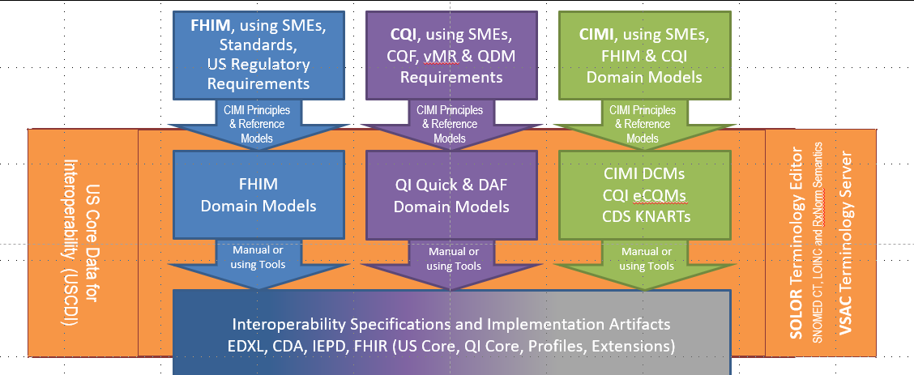

**Figure 8: HL7-CIMI Data-Quality Risk Mitigation Methodology.**

ONC TEFCA and NIST CSF provide a trusted smart healthcare environment; where, Health care organizations extend their focus to customer-centered relationship to more effectively serve, communicate with, and maintain patient value (safety, care, cost). A successful transition to value-based care requires that market players and consumers move beyond transaction-based treatment to the holistic health of populations; from treatment to prevention/wellness; and from individual to population health. Health care providers can also look at deploying innovative care delivery models based on data and analytics. Ever-evolving policies, processes, and capabilities and the given magnitude and complexity impacting the healthcare landscape, smart health care is not going to come easy and benefits from agile model-driven development. health IT encoding-layer's normalization with fully-qualified USCDI-FHIM-CIMI logical design-specification structural-models resulting in clear, complete, concise, correct and consistent operational EDXL, FHIR, C-CDA, IEPD APIs and components. SOLOR models-of-meaning empower data-sharing empowering population-analytics and decision-support reasoning, which can positively impact patient safety and quality of care while reducing costs, as notionally shown below.

The *benefit* of standard USCDI-FHIM-CIMI Reference Data-and-Models for consistent Detailed Clinical Model (**DCM**) constrained-specifications for EDXL, FHIR, CDA and IEPD is an Architectural Framework for computable semantic-interoperability across time, locations, systems and care contexts. Seamless tools can result in efficient-and-effective federated mission-essential re-usable “stack” of standardized and widely implemented HSPC APIs, “SMART” components and test fixtures using SOLOR controlled terminologies.

* collection, extraction-transformation-load, communication, aggregation and interpretation of patient data to accelerate secondary uses in public health, disease surveillance, metrics, and patient-centered outcomes research.
* health-related services including telecare, clinical decision support, research, and quality measurement, improving healthcare access, quality, and uniformity.
* Major patient, clinician, and public benefits from improved care coordination, reduction of medical errors, and decreased costs resulting in healthier lives.

**Summary**

1. **Goal**: Computable-interoperability among ad-hoc partners using heterogeneous systems
   * Consistent US Realm/Core structure specification and terminology value sets for
     + V2 messages
     + C-CDA templates
     + FHIR profiles and extensions
     + Information Exchange Package Documents (IEPDs)
     + Reference (Implementation Guides, APIs, implementation components)
     + “Dummies Guide” for clinical users, analysts, architects, engineers and implementers.
2. **Data-Quality Requirement 1**: Bi-directional mapping, without losing information, between
   * EHR data-entry, reporting and viewing pre-coordinated form to
   * EDW analytic-normalized post-coordinated form for population healthcare and CDS reasoning.
3. **Data-Quality Requirement 2**: Governed and versioned SNOMED CT extension for LOINC and RxNorm
   * using Model Driven Development (MDD) Tools, including
     + USCDI-FHIM harmonized domain-models, creating
   * Freely available context-specific Detailed Clinical Models / Clinical Statements
     + Context-specific pre-post coordinated form DCM templates bound to
   * Freely available terminology value sets
     + for HIEs, venders,
     + healthcare-partners
4. **Challenge**: Data quality solutions that are both optimized for clinician pre-coordinated data entry form require bi-directional mapping, without loss of information. to normalized analytic post-coordinated form; where clinical findings have associated-context, which can be multi-faceted, including workflow, provenance and intended use.
5. **EHR-EDW Requirements:** clear, complete, concise, correct and consistent data, which is traceable.
   * Data entry and billing EHR, legacy data, ancillary systems and partner systems feeding Data analytics EDW
   * Monthly reports; where, EDW queries/analytics can be optimized for canned data-entry viewing and reporting.
   * Timely surveillance data-feeds satisfied by a speedy EHR ETL to EDW process, which includes on-the fly data cleansing and bi-directional data entry form to data analytic form mapping, without loss of information.
   * Point-of-care information, population-based knowledge-analytics and CDS-reasoning.
6. **Emergency-Management Scenario/Use-case Scope**: Wounded-Warrior and Natural-Disaster management patient-movement across a Continuum-of-Care Scenario and Healthcare IT use-case; where, Information must move with patients.
7. **New Emergency-Management Requirements**: computable-interoperability amongst disparate partners collaborating with an ad-hoc set of heterogeneous systems, during a disaster response patient-movement episode across the continuum-of-care enabled by bi-directional, without loss of information ETL mapping using a SNOMED extension for RxNorm.
8. **Issue**: TEFCA-USCDI, EHR-EDW modernization data-integrity risk including legacy data and Health Information Exchange (**HIE**) partners, among Qualified QHINs and the Recognized Coordinating Entity (**RCE**) relationships.
   * due-to pre-coordinated data-representations for data entry, viewing, reporting and alerts
   * Inconsistently mapped-to post-coordinated data-representations for analytics, reasoning and vice-versa,
   * complicated by different granularities and ontologies within-and-across controlled vocabularies and code sets,
9. **Approach**: “*fit for use”* strategy enabling clinical analytics, reasoning and decision support.
   * Pre-coordinated data entry for EHR entry and viewing is preferable; where,
     + Context meta-data collection/analysis/timeliness should be based on the intended use, e.g.,
   * specific requirements use-cases, e.g., reporting, analytics, reasoning, decision support
   * specific implementation-specification Detailed Clinical Models (DCMs)
   * Post-coordinated “canned” EDW analytics, viewing and reporting are preferable; where,
     + EDW can be optimized for multiple pre-defined use-cases/schemas/queries, considering
   * Cost/quality of real-time transactional data vs. cost/quality of EDW canned views/reports.
   * Outcomes measurements.
   * Post-coordinated point-of care analytics and clinical decision support reasoning within scope.
   * real-time ad-hoc post-coordinated transactional analytics and reasoning can be high risk/cost and must have a use-case with a significant return-on-investment.
   * Point-of-care real-time lessons learned should influence “canned” EDW analytics over time
10. **Recommendation**: A focused tiger team align the many practical informatics considerations, technologies, methodologies and tools into a TEFCA-USCDI-FHIM-CIMI-SOLOR data-quality stewardship and governance process, incorporating ONC-FHA-HL7-HSPC-NIEM technologies, methodologies and tools to empower efficient-and-effective bi-directional, without loss of information, pre/post coordinated US Core Data for Interoperability and US SNOMED extension for LOINC and RxNorm terminology. One or more Federal government EHR modernizations can be a high-value pilot-study computable interoperability and Health Information Networks (HIN) partners and among Qualified QHINs. This can positively influence the RCE and QHINs by sharing the ETL pre-post coordinated USCDI mappings and value sets within an HHS: FHA managed US Core Data for Interoperability and US realm SNOMED extension for LOINC and RxNorm. Next-Steps:
11. Harmonize USCDI-FHIM-OASIS-HL7-NIEM data elements
12. Integrate SOLOR terminology and value sets
13. Standardize FHIR-CCDA-EDXL-IEPD implementation guides
14. “*Dummies Guide* for TEFCA-USCDI-FHIM-OASIS-HL7-NIEM-HSPC standards, policies, methodologies, technologies and model-driven-development tools”.
15. Seamless open-source model-driven-development tool stack (MDHT, MDMI, ISAAC) with clinician GUI
16. Reference EDXL-FHIR-CDA-IEPD APIs, components and test fixtures.
17. Clinical and implementation mentor-SME hands-on hackathons and connections, e.g., HL7, HIMSS showcase.
18. Professional society papers and presentations,
19. Conformance and/or certification specifications, procedures, fixtures and tools.
20. **Benefit**: Positively impact computable interoperability within-and-among Health Information Exchange (**HIE**) partners, among Qualified QHINs and the Recognized Coordinating Entity (**RCE**) by sharing the ETL bi-directional, without loss of information, and value sets within SOLOR (SNOMED LOINC, RxNorm) US Realm extension. Improved computable semantic-interoperability empowers better analytics, reasoning, and outcomes measurements and Patient Value (Safety, Quality, Cost).

**Conclusion**:

Due to differing code systems’ purpose, both granularity and clinical-context attributes typically make pre/post coordination and cross clinical vocabulary mapping ambiguous for population health analytics and reasoning. A systematic context-specific mapping between EHR files and tables with EDW analytics can be 1:1 round-trip-able; where pre-planned data entry can avoid poor analytics performance. HL7 is standardizing and HSPC is operationalizing the pre-requisite methodologies, technologies and tools. The findings in this paper are applicable to any EHR, EDW and data sharing situation. The conundrum and recommended risk-mitigation strategy is universally applicable.

Specifically, EHR-EDW ETL might be improved, where, The EHR files and tables for Clinical Input form (**CIF**) must have explicit 1:1 mappings to EDW analytic Normalized Forms (**ANF**). The end-of day ETL process will be different from the target CIMI/SOLOR-supported isosemantic model approach to produce FHIR, CDA etc.

* The iso-semantic model constructs a path from clinical process data to CIF models. Those might not be implemented by any operational system, but used in a support service that offers knowledge-based insight to the operational system. But for that to work, the input process data must be defined in semantically specific clinical models. *Right now, it's not*.
* ETL is a migration path that will need to be formalized and governed soon, e.g., the smoking status property will likely be supported by a point-to-point context-specific ETL rule.
* CIMI, SOLOR and EHR modernization rules supported or defined by the semantic models should be harmonized; because, CIF1 and the same CIF2,in different care locations must not always result in same semantics as CIF1 to ANF, e.g., smoking status.
* The call to action to benefit from the recommendations in this paper data-quality data-stewards and governance plus their integration and deployment contractors must engage quickly.
* The consequences of inaction are to degrade computable semantic interoperability resulting in degraded patient value (safety, quality, cost).

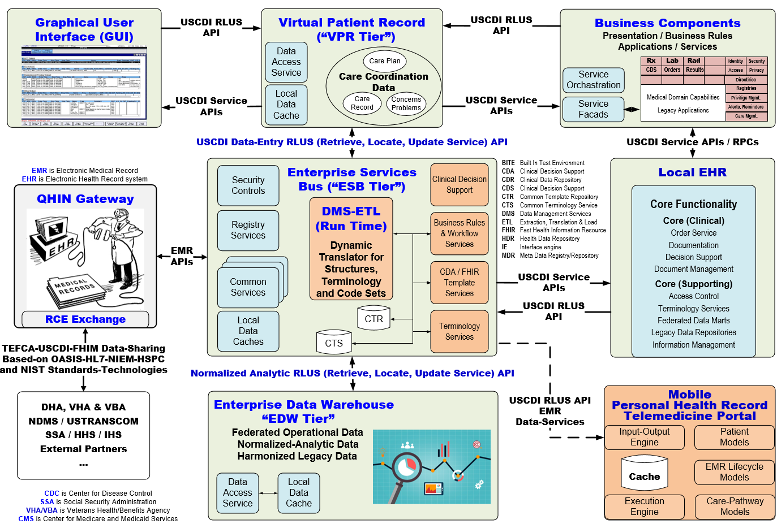

**Figure 9: Notional EHR Modernization Data-Quality Strategy (TEFCA-USCDI-FHIM-HL7-OASIS-NIEM-HSPC-MITRE)**

**APPENDIX: Notional example of inherent pre/post coordination ambiguity**

We present a simple, pre/post coordination mapping example of ICD-10 pre-coordinated code mapped to SNOMED CT post-coordinated expression to illustrate the multi facets of workflow, context-provenance and intended use contributing to the data quality conundrum, with respect to analytics and reasoning. This notional example is arbitrary and incomplete; because, it does not include the fully specified full episode-of-care using the SNOMED observation model’s finding type + context with SNOMED expressions and descriptive logic that empowers the efficient-and-effective reasoning needed for “real-time” patient-care encounter-support mobile-app services.

Neck of the Femur was chosen because hip related injuries are common in elderly patient falls and it is intuitive. A closed displaced fracture was chosen for its simplicity to demonstrate pre/post coordination coding ambiguity. We did not choose the more interesting open fracture, also called a compound fracture, in which there is an open wound or break in the skin near the site of the broken bone. Most often, this wound is caused by a fragment of bone breaking through the skin at the moment of the injury.

An open fracture was rejected, because, it requires different treatment than a closed fracture, in which there is no open wound, yet, the ICD-10 code includes both fracture types. Once the skin is broken, bacteria from contaminants can enter the wound and cause infection; where, early treatment for an open fracture focuses on cleansing the wound and preventing infection at the site of the injury. In both cases, the fractured bone must be stabilized to allow healing.

**Vignette**: 70 YO Patient fell on ice and presents to the ED; where, Orthopedics is called for evaluation and treatment of a type III closed displaced-fracture of the neck of the femur of the right leg.

**2018 ICD-10-CM Diagnostic Code: S92.001 type III**; where,the following fractures are type III:

* segmental fracture with displacement
* fracture with diaphyseal segmental loss;
* fracture with associated vascular injury requiring repair;
* farmyard injuries or highly contaminated wounds;
* high velocity gunshot wound;
* fracture caused by crushing force from fast moving vehicle;

The appropriate 7th character is to be added to all codes from category S52 (unless otherwise indicated). A initial encounter for closed fracture B initial encounter for open fracture type I or II initial encounter for open fracture NOS C initial encounter for open fracture type IIIA, IIIB, or IIIC D subsequent encounter for closed fracture with routine healing E subsequent encounter for open fracture type I or II with routine healing F subsequent encounter for open fracture type IIIA, IIIB, or IIIC with routine healing G subsequent encounter for closed fracture with delayed healing H subsequent encounter for open fracture type I or II with delayed healing J subsequent encounter for open fracture type IIIA, IIIB, or IIIC with delayed healing K subsequent encounter for closed fracture with nonunion M subsequent encounter for open fracture type I or II with nonunion N subsequent encounter for open fracture type IIIA, IIIB, or IIIC with nonunion P subsequent encounter for closed fracture with malunion Q subsequent encounter for open fracture type I or II with malunion R subsequent encounter for open fracture type IIIA, IIIB, or IIIC with malunion S sequela.

**SNOMED CT**

Pre-coordinated Expression (*)

**239284006 |Primary open reduction of fracture of neck of femur and open fixation using Charnley compression screw (procedure)|**

**Expression from Stated Concept Definition (*)**

**<<< 179035002 |Primary open reduction of fracture and internal fixation with screw(s) (procedure)| :  
 { 424226004 |Using device (attribute)| = 68183006 |Bone screw, device (physical object)|,   
 260686004 |Method (attribute)| = 129371009 |Fixation - action (qualifier value)|,   
 363700003 |Direct morphology (attribute)| = 72704001 |Fracture (morphologic abnormality)|,   
 246513007 |Revision status (attribute)| = 261424001 |Primary operation (qualifier value)|,   
 405813007 |Procedure site - Direct (attribute)| = 29627003 |Structure of neck of femur (body structure)| }  
 { 363700003 |Direct morphology (attribute)| = 72704001 |Fracture (morphologic abnormality)|,   
 260686004 |Method (attribute)| = 426530000 |Open reduction - action (qualifier value)|,   
 246513007 |Revision status (attribute)| = 261424001 |Primary operation (qualifier value)|,   
 405813007 |Procedure site - Direct (attribute)| = 29627003 |Structure of neck of femur (body structure)| }**

**Expression from Inferred Concept Definition (*)**

**<<< 57470004 |Open reduction of fracture of femur with internal fixation (procedure)| +   
 80742007 |Fixation of hip (procedure)| +   
 179035002 |Primary open reduction of fracture and internal fixation with screw(s) (procedure)| :  
 { 424226004 |Using device (attribute)| = 68183006 |Bone screw, device (physical object)|,   
 260686004 |Method (attribute)| = 129371009 |Fixation - action (qualifier value)|,   
 700003 |Direct morphology (attribute)| = 72704001 |Fracture (morphologic abnormality)|,   
 246513007 |Revision status (attribute)| = 261424001 |Primary operation (qualifier value)|,   
 405813007 |Procedure site - Direct (attribute)| = 29627003 |Structure of neck of femur (body structure)| }**

**{ 363700003 |Direct morphology (attribute)| = 72704001 |Fracture (morphologic abnormality)|,   
 260686004 |Method (attribute)| = 426530000 |Open reduction - action (qualifier value)|,   
 246513007 |Revision status (attribute)| = 261424001 |Primary operation (qualifier value)|,   
 405813007 |Procedure site - Direct (attribute)| = 29627003 |Structure of neck of femur (body structure)| }**